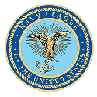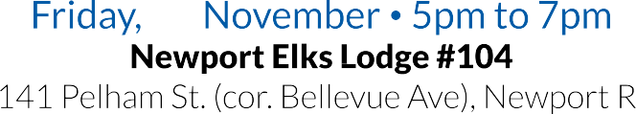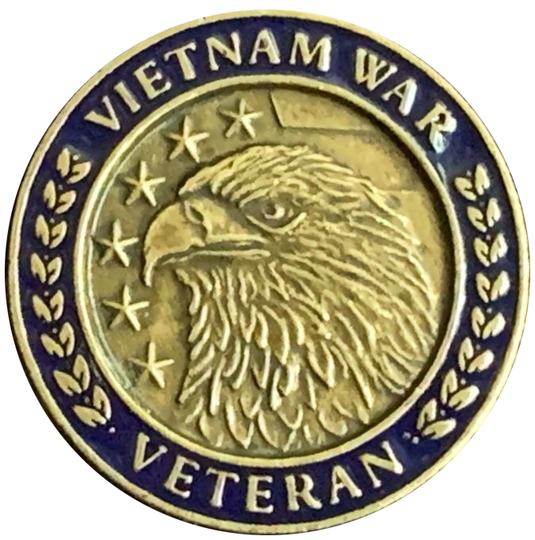

**Newport County Council**

**Navy League of the United States**

**50th Anniversary Lapel Pin Presentation**

***Please Complete The Section Below and Return to:***

# Len DiLorenzo NCCNLUS Commemorative Partner Coordinator at [amglad1@comcast.net](mailto:amglad1@comcast.net) OR Text your info or questions to (401) 440 4089

If you are a Vietnam Vet bringing guests fill out your Vet details and sign up your Guests under Guest Response

# Vietnam Veteran Response

You must register to reserve your pin. Attendance is free. + 1 complimentary beer or wine Name:       Rank:       Service:       Active Duty (mm/yy):       to

# Member & Guest Response $22 Per Person. No Host Bar.

Donation Amount $     ______  Card  Check  Cash at Door

Name       Additional Guests      ___ x $22 Total $      Email address       Organization:      Credit Card #       Xp. Date (mm/yy)   __/  __ CCV    _ Zip       Name:       (on card) OR make check out to NCCNLUS and mail to:



